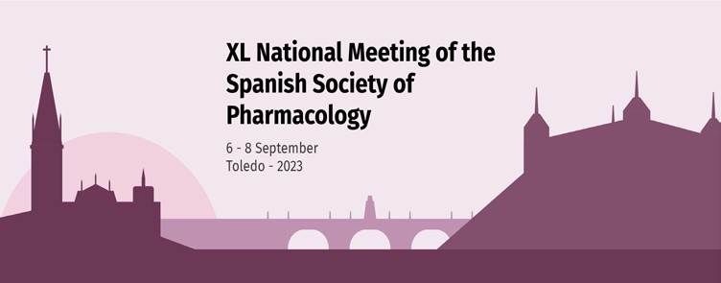

XL National Meeting. Spanish Society of Pharmacology
Toledo 6-8 September 2023

Registration form.
Send it, along with the transfer receipt to: socesfar@socesfar.es

Surname and first name:

Department:

Institution:

Postal address:

Zip code:

Population: Province: Country:
e-mail: Phone:
Registration fees

Participant | Until May 31 | From June 1
SEF Members (Ordinary) | 350,00 € | 450,00 €
SEF Members (Student) | 175,00 € | 250,00 €
Non-SEF Members (Ordinary) | 450,00 € | 550,00 €
Non-SEF Members (Students*) | 225,00 € | 300,00 €
Accompanions | 100,00 € | 150,00 €

Inscription

Concept | Quantity | Unit Price | Total price
Registration fee
Accompanying person |  | 100 €
Closure dinner |  | 60 €
 | Total registration

How to pay: Bank transfer to: Sociedad Española de Farmacología
IBAN: ES74 0075 0227 7006 0051 0915

(Attach the justification of payment to the registration form)

I have read and accept the legal conditions
Administrative Secretary of the congress: Mar Morales - socesfar@socesfar.es

XL National Meeting. Spanish Society of Pharmacology. Toledo, September 6-8, 2023

